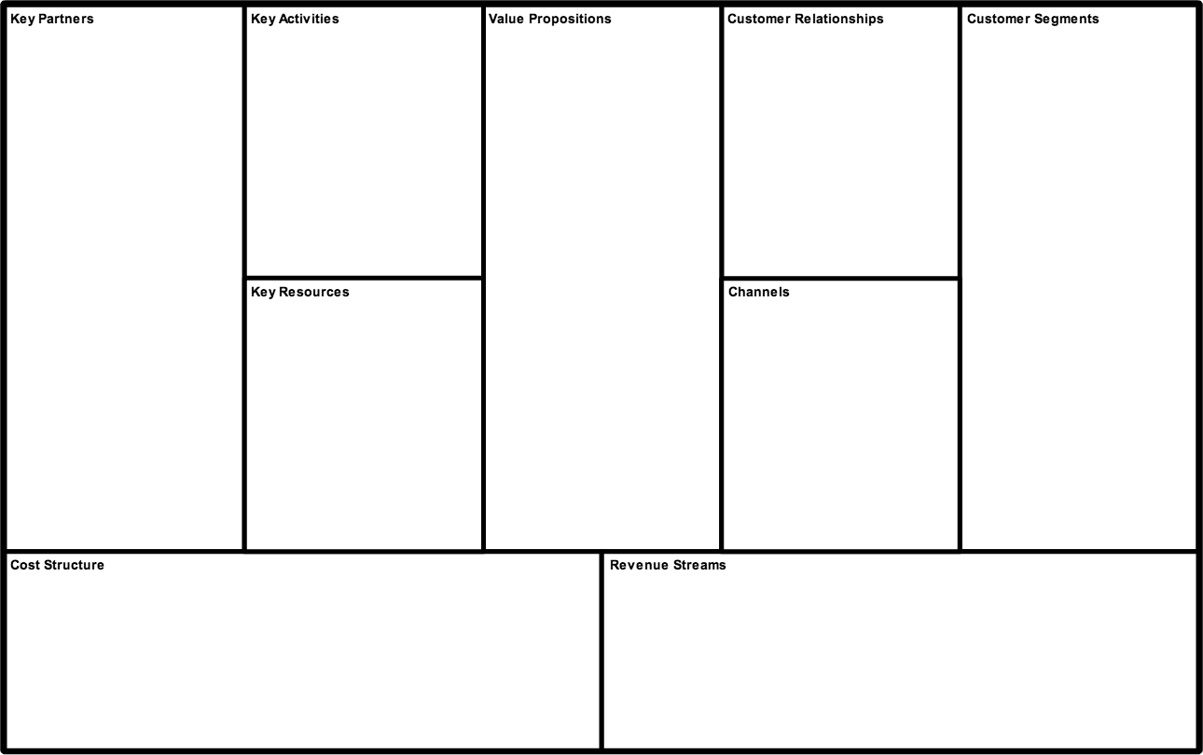

The customer in this case is not the user. Both will be specified.

Customer:
Companies owning the most popular video editing tools. (e.g. Adobe, Microsoft, Sony)

User:
Professional cutters / hobbyist video producers. The typical user will have some experience in video editing. Somebody starting out with video editing will not worry about the problems we solve.

Game-Changing:
Our technology does not exist yet and will solve the problem of data clutter and organization issues in video editing.
Video editing tools implementing out technology will therefore have an advantage over others.

Qualitative:
The technology will work with all major video formats (MP4, WMV, AVI, MOV, FLV). This will make our tool more generally useful.

Quantitative:
We plan to create a space for a community to talk about our technology. We will listen to them closely and update our software frequently according to their wishes and needs.

To Customer:
Communication with our customer will happen via e-mail contact and personal meetings.

To User:
Since our technology will be part of our customers product, they will take care of reaching the users and selling the idea to them. To maintain user satisfaction, we will set up FAQs, usage guides, contact e-mails and an online community for discussion.

To Customer:
To the customer, we provide dedicated assistance. When ever there is a problem concerning our addition to their product, it will be our responsibility to resolve it. They will have a contact which will be available 5 days a week.

To User:
For the users there will be an online community set up around our technology, in which employees will be active answering questions and identifying concerns and wishes. There will also be automated service in form of FAQs.
Our technology will be sold to big players like Microsoft, Adobe and Sony for their video editing software. We will collect a periodic fee for the usage of our technology. In exchange for that fee, we will maintain the software and make necessary and wanted changes. The fee will partly be static and partly tied to the revenue generated by the software using it.
There will be no revenue stream coming from the users.

Our main resource will be knowledge. We are selling a novel technology, which inner workings are not known to outsiders.

The next most important resource are our employees. They carry the knowledge and make communication via an online community possible. If the community grows too large, more employees will be needed. Which requires the last obvious resource: money.

Our key activity will be maintaining the technology, because this is what we will get paid for.

Also we will stay in contact with other potential customers, to sell them our technology.

Lastly we will continue research & development for new data-types, in order to expand our business.

Since a part of our activities is research & development, we will partner up with universities. We will give multiple researchers a place to work, in exchange for their knowledge and research ability.

Our most important partners are of course our customers. We will develop a part of their product and thus establish a buyer-supplier alliance.

Our company will work value driven. Once the technology is finished, there will be little cost. We will mainly get requests on how to improve our product and we will follow those requests. Since the results of our maintenance work and the payment, which we receive will be independent, there is less room for maximizing cost efficiency.
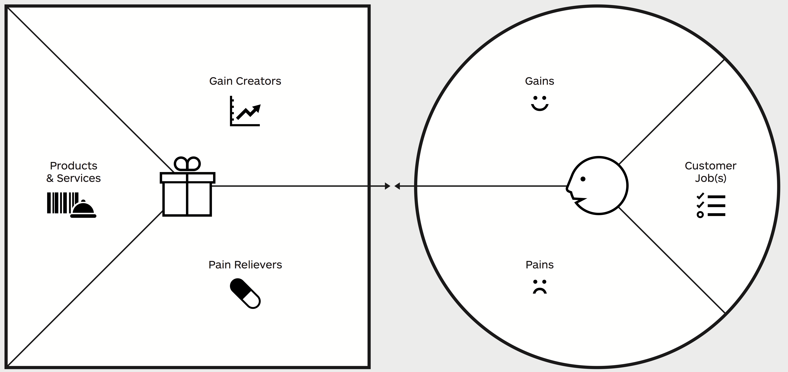
-editing videos / films
-organizing edited data
-selling good video editing
software
-developing video editing
software to fit the state of the
art
-huge data usage when having
multiple versions of videos
-difficulties in organization with
multiple versions of videos
If competitors use our technology:
-lagging behind in the current
state of the art for video
editing software
-easy organization of video data
-less memory clutter because of
video data
-easier and more access to old
versions of video data
-furthering development in video editing technology
-going with the state of the art
-keeping customers happy
-organizing multiple video versions into:
1 video + version specific differences.
This will save memory in comparison to
saving one file per version
-This approach will also make
organization of video versions simpler
We will advertise our product to one big player. Once he implements it, we will have created the pain in his competitors of lagging behind in the state of the art. We will then relieve that pain by selling them the product too.
-gain of a temporal advantage
over competition, due to
superior technology (This
only works in the beginning)
-bonus of being able to store a greater amount of
different versions
-being able to switch to versions which otherwise
wouldn’t have been saved
A version-control system, which works on video data, making video editing and versioning easier.
Adding a novel piece of technology to their video editing software.
Customer
User
Short idea explanation:
My idea is a version control system (like Git or SVN) for video data. My plan is to sell this idea to developers of popular video editing software, so that they can integrate it into their product. My customers are therefore the developers and my users the users of my customers software.

